Mini Project Report

Subject: INT 247 Machine Learning Foundation


Student Name: Soham Kulkarni
Reg. No.: 11604555
Section: KEM21
Roll. No.: B46

Topic: Dermatology Dataset

Submitted to: Dr. Prateek Agrawal

1. Objective

On the given dermatology data perform the following
- Bulding Feature set
- Creating Train test split
- Evaluate the accuracy of random forest with number of estimator =3
- Find best value of number of estimator for better performance

2. Dataset Description

This database contains 34 attributes, 33 of which are linear valued and one of them is nominal.
The differential diagnosis of erythemato-squamous diseases is a real problem in dermatology. They all share the clinical features of erythema and scaling, with very little differences. The diseases in this group are psoriasis, seboreic dermatitis, lichen planus, pityriasis rosea, cronic dermatitis, and pityriasis rubra pilaris. Usually a biopsy is necessary for the diagnosis but unfortunately these diseases share many histopathological features as well. Another difficulty for the differential diagnosis is that a disease may show the features of another disease at the beginning stage and may have the characteristic features at the following stages. Patients were first evaluated clinically with 12 features. Afterwards, skin samples were taken for the evaluation of 22 histopathological features. The values of the histopathological features are determined by an analysis of the samples under a microscope.
In the dataset constructed for this domain, the family history feature has the value 1 if any of these diseases has been observed in the family, and 0 otherwise. The age feature simply represents the age of the patient.
Every other feature (clinical and histopathological) was given a degree in the range of 0 to 3. Here, 0 indicates that the feature was not present, 3 indicates the largest amount possible, and 1, 2 indicate the relative intermediate values.

Attribute Information:
Clinical Attributes: (take values 0, 1, 2, 3, unless otherwise indicated)  1: erythema  2: scaling  3: definite borders  4: itching  5: koebner phenomenon  6: polygonal papules  7: follicular papules  8: oral mucosal involvement  9: knee and elbow involvement  10: scalp involvement  11: family history, (0 or 1)  34: Age (linear) | Histopathological Attributes: (take values 0, 1, 2, 3)  12: melanin incontinence  13: eosinophils in the infiltrate  14: PNL infiltrate  15: fibrosis of the papillary dermis  16: exocytosis  17: acanthosis  18: hyperkeratosis  19: parakeratosis  20: clubbing of the rete ridges  21: elongation of the rete ridges  22: thinning of the suprapapillary epidermis  23: spongiform pustule  24: munro microabcess  25: focal hypergranulosis  26: disappearance of the granular layer  27: vacuolisation and damage of basal layer  28: spongiosis  29: saw-tooth appearance of retes  30: follicular horn plug  31: perifollicular parakeratosis  32: inflammatory monoluclear inflitrate  33: band-like infiltrate

3. Model Description

How does the algorithm work?
It works in four steps:
- Select random samples from a given dataset.
- Construct a decision tree for each sample and get a prediction result from each decision tree.
- Perform a vote for each predicted result.
- Select the prediction result with the most votes as the final prediction.

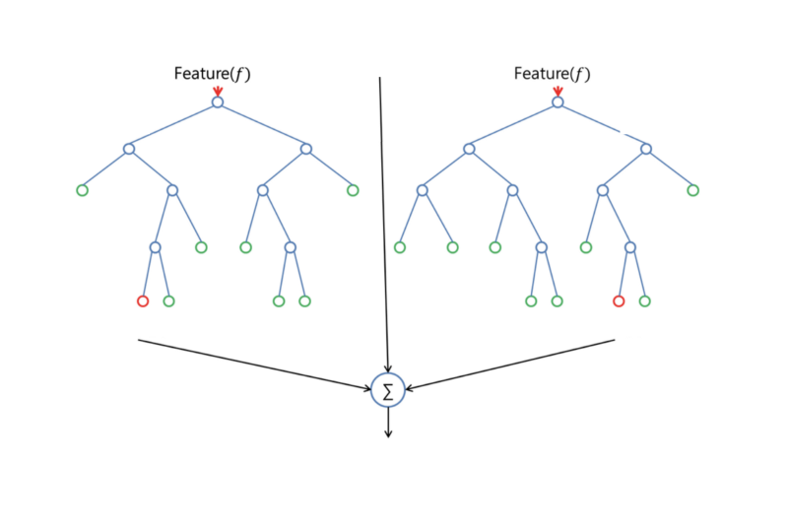
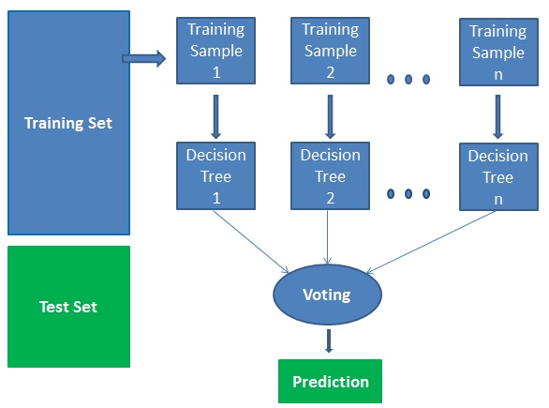

Advantages:
- Random forests is considered as a highly accurate and robust method because of the number of decision trees participating in the process.
- It does not suffer from the overfitting problem. The main reason is that it takes the average of all the predictions, which cancels out the biases.
- The algorithm can be used in both classification and regression problems.
- Random forests can also handle missing values. There are two ways to handle these: using median values to replace continuous variables, and computing the proximity-weighted average of missing values.
- You can get the relative feature importance, which helps in selecting the most contributing features for the classifier.

Disadvantages:
- Random forests is slow in generating predictions because it has multiple decision trees. Whenever it makes a prediction, all the trees in the forest have to make a prediction for the same given input and then perform voting on it. This whole process is time-consuming.
- The model is difficult to interpret compared to a decision tree, where you can easily make a decision by following the path in the tree.

Finding important features
Random forests also offers a good feature selection indicator. Scikit-learn provides an extra variable with the model, which shows the relative importance or contribution of each feature in the prediction. It automatically computes the relevance score of each feature in the training phase. Then it scales the relevance down so that the sum of all scores is 1.
This score will help you choose the most important features and drop the least important ones for model building.
Random forest uses gini importance or mean decrease in impurity (MDI) to calculate the importance of each feature. Gini importance is also known as the total decrease in node impurity. This is how much the model fit or accuracy decreases when you drop a variable. The larger the decrease, the more significant the variable is. Here, the mean decrease is a significant parameter for variable selection. The Gini index can describe the overall explanatory power of the variables.

Random Forests vs Decision Trees
- Random forests is a set of multiple decision trees.
- Deep decision trees may suffer from overfitting, but random forests prevents overfitting by creating trees on random subsets.
- Decision trees are computationally faster.
- Random forests is difficult to interpret, while a decision tree is easily interpretable and can be converted to rules.

4. Code Snippets

import numpy as np
import pandas as pd
from sklearn.model_selection import train_test_split
df = pd.read_csv("derm.csv")

df.fillna(np.nan,inplace=True)
df.fillna(df.loc[0:,'age'].mean(),inplace=True)

import matplotlib.pyplot as plt
import seaborn as sns
f, ax = plt.subplots(figsize=(10, 8))
corr = df.corr()
sns.heatmap(corr,mask=np.zeros_like(corr,dtype=np.bool),cmap=sns.diverging_palette(220,2, as_cmap=True),square=True, ax=ax)
df.corr()

df.drop(['polygonal_papules','vacuolisation_and_damage_of_basal_layer','saw-tooth_appearance_of_retes',
'perifollicular_parakeratosis', 'inflammatory_monoluclear_inflitrate',
'band-like_infiltrate'],axis=1,inplace=True)

X = df.drop(['class'], axis=1)
y = df['class']
X_train, X_test, y_train, y_test = train_test_split(X, y, test_size=0.3)

from sklearn.ensemble import RandomForestClassifier
#Create a Gaussian Classifier
clf=RandomForestClassifier(n_estimators=3 ,oob_score = True, n_jobs = -1,random_state =50)

#Train the model using the training sets y_pred=clf.predict(X_test)
clf.fit(X_train,y_train)
y_pred=clf.predict(X_test)

#Import scikit-learn metrics module for accuracy calculation
from sklearn import metrics
# Model Accuracy, how often is the classifier correct?
print("Accuracy:",metrics.accuracy_score(y_test, y_pred))

#Create a Gaussian Classifier
clf=RandomForestClassifier(n_estimators=28 ,oob_score = True, n_jobs = -1,random_state =50)

#Train the model using the training sets y_pred=clf.predict(X_test)
clf.fit(X_train,y_train)
y_pred=clf.predict(X_test)

# Model Accuracy, how often is the classifier correct?
print("Accuracy:",metrics.accuracy_score(y_test, y_pred))

import pandas as pd
feature_imp = pd.Series(clf.feature_importances_,index=X.columns).sort_values(ascending=False)
feature_imp

import matplotlib.pyplot as plt
import seaborn as sns
%matplotlib inline
# Creating a bar plot
sns.barplot(x=feature_imp, y=feature_imp.index)
# Add labels to your graph
plt.xlabel('Feature Importance Score')
plt.ylabel('Features')
plt.title("Visualizing Important Features")
plt.legend()
plt.show()

